**6. Prototypes of inputs, output and user Interface**

* 1. **Inputs**

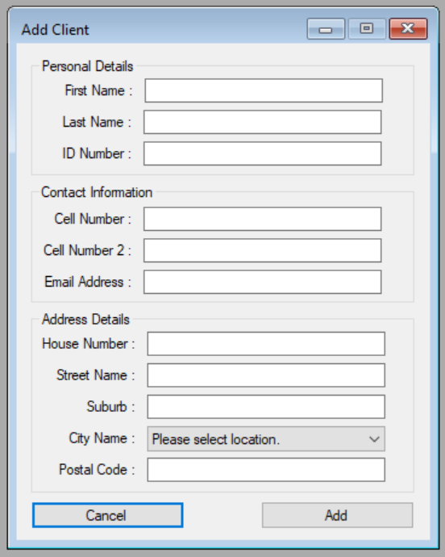

**Figure 1. Add Client**

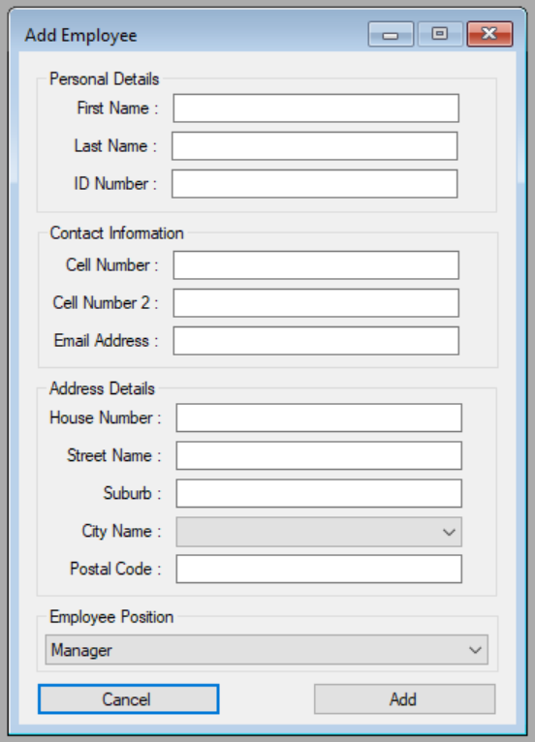

**Figure 2. Add Employee**

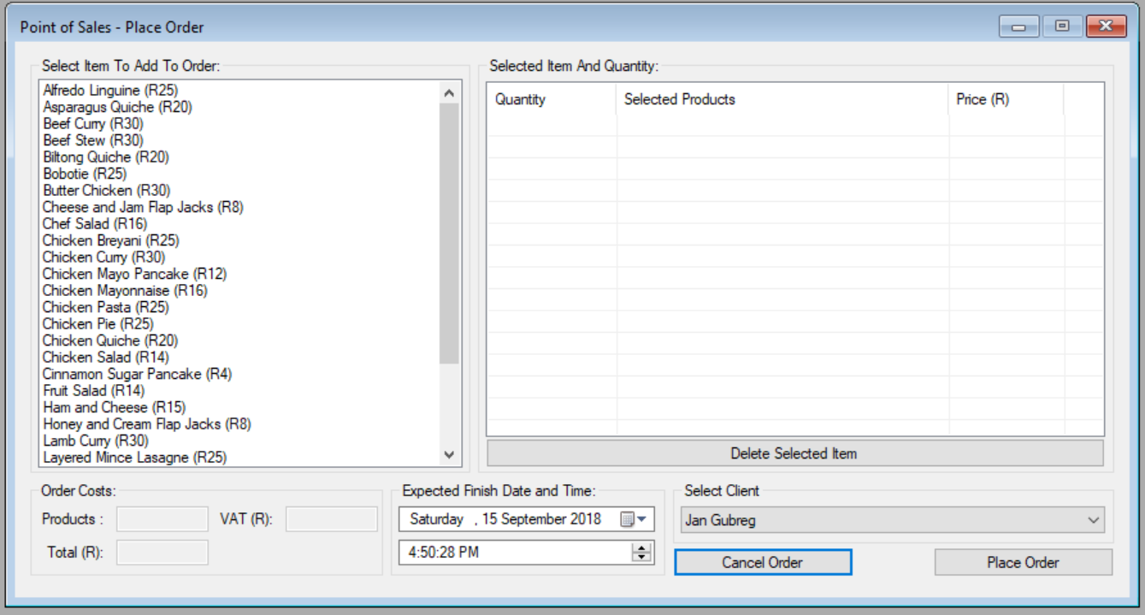

**Figure 3. Place Order**

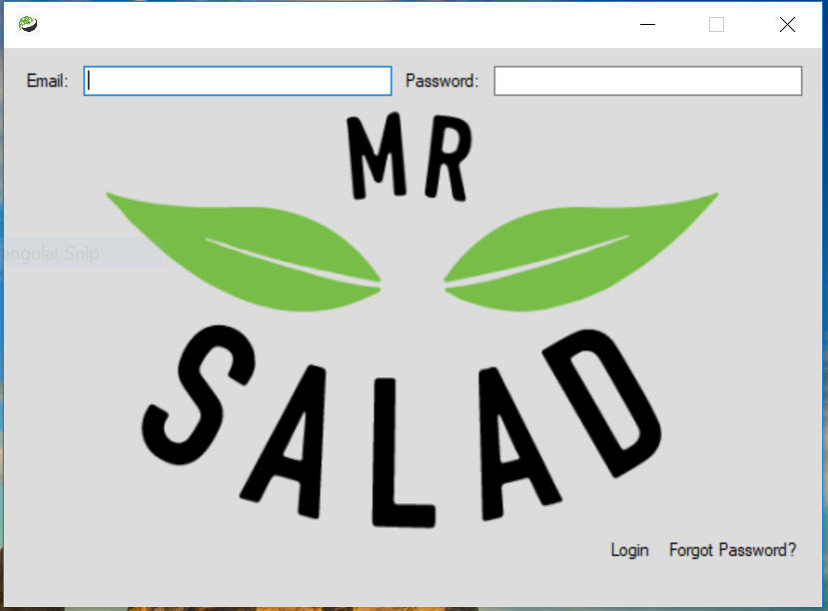

**Figure 4. Login Screen**

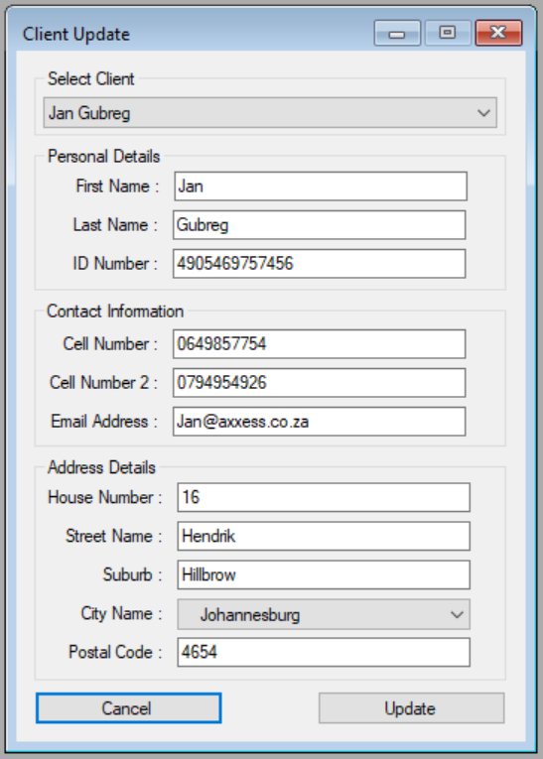

**Figure 5. Update Client**

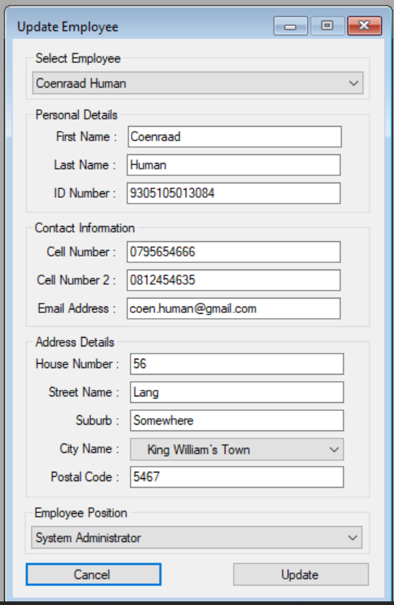

**Figure 6. Update Employee**

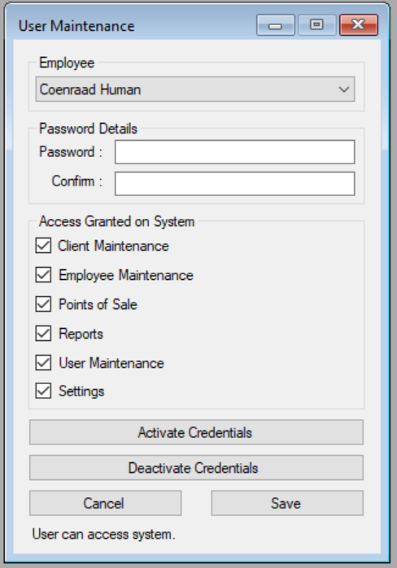

**Figure 7. User Maintenance**

* 1. **Outputs**

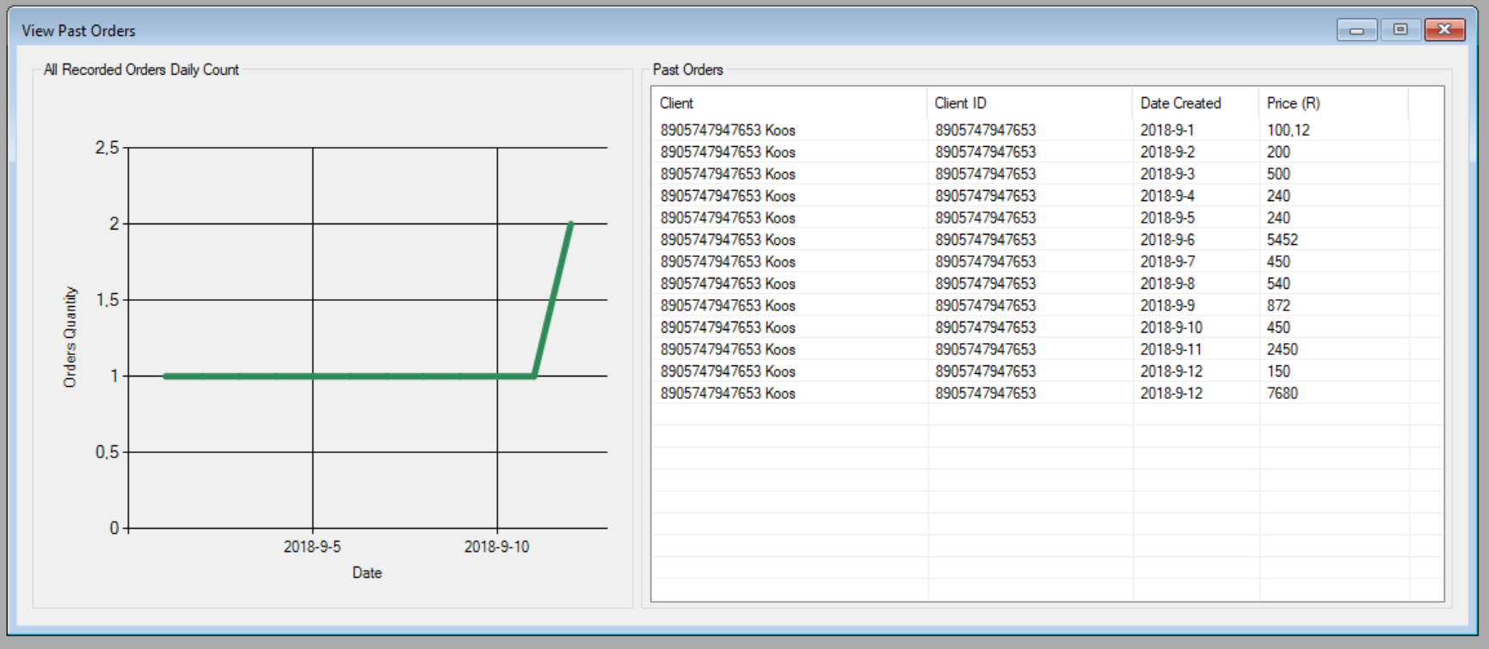

**Figure 8. Past Orders**

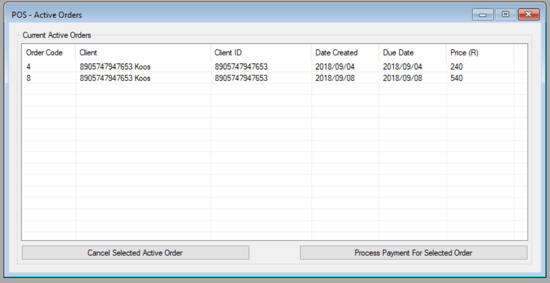

**Figure 9. Active Orders**

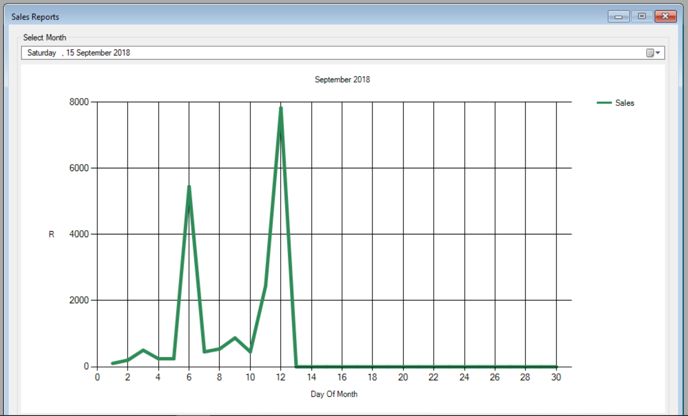

**Figure 10. Sales Report**

* 1. **Interface**

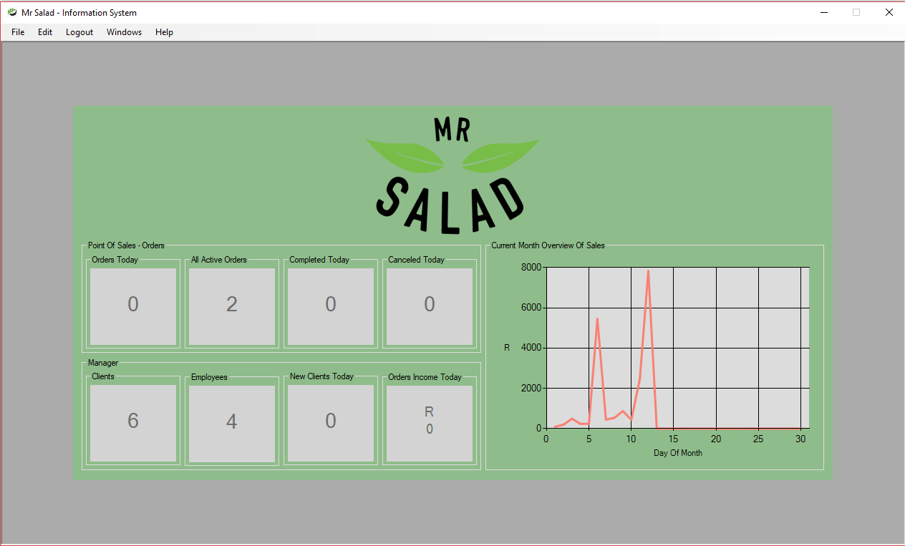

**Figure 11. Dashboard**